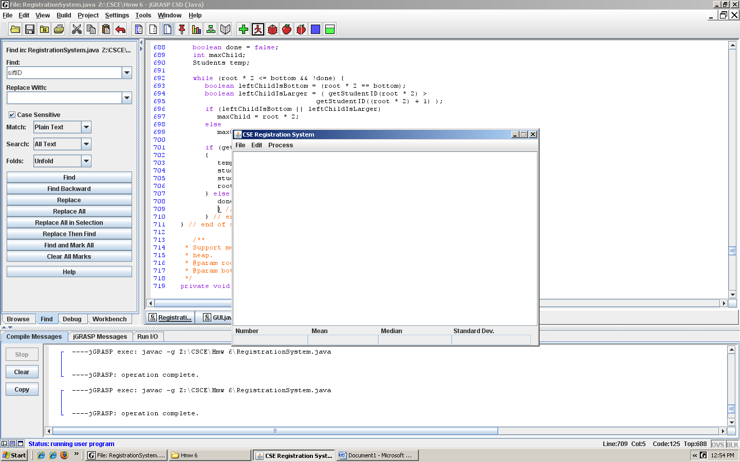
The main GUI.
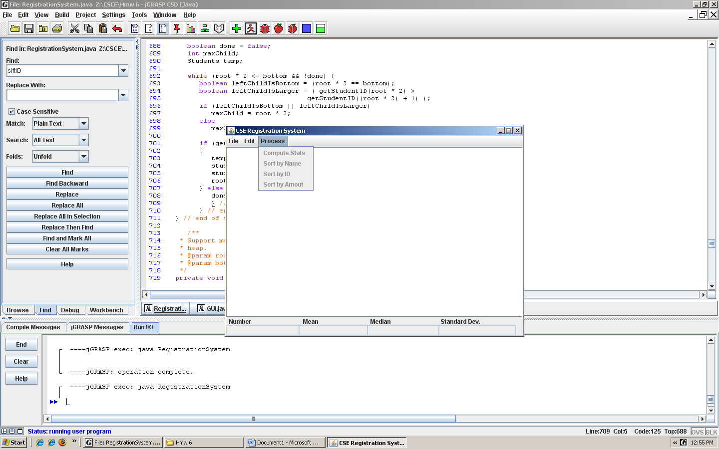
Every Process Gray out prior to load a file.
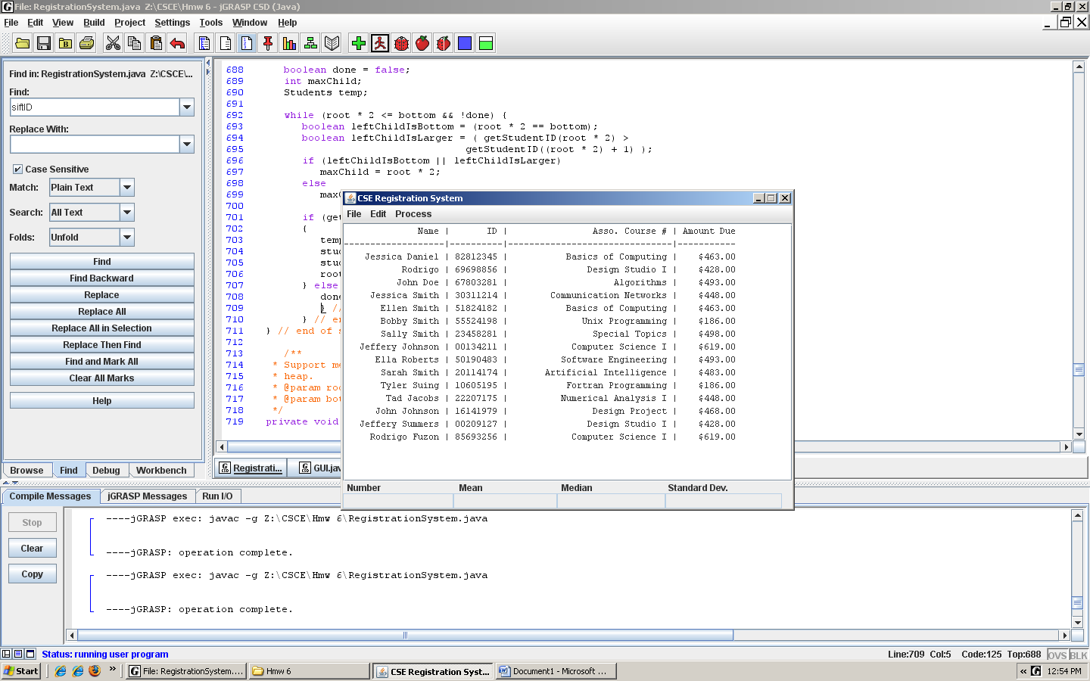
Students Load File.
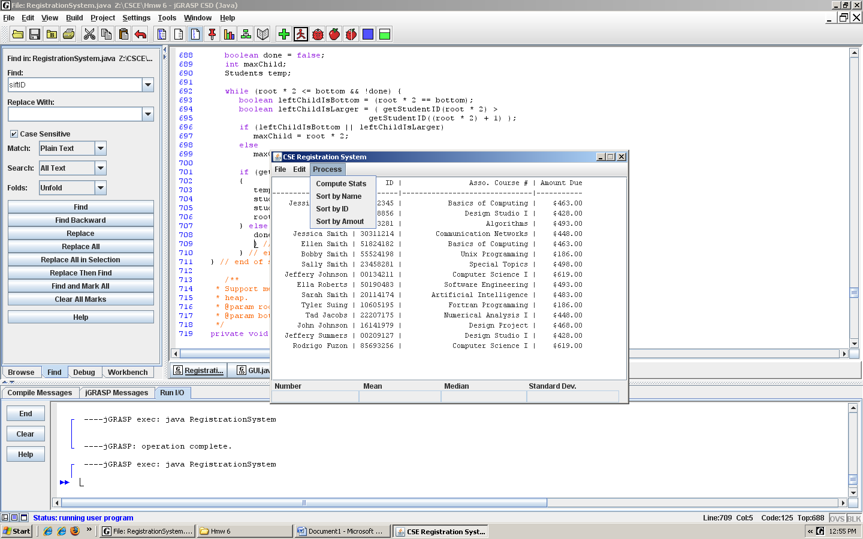
Information Available to Click.
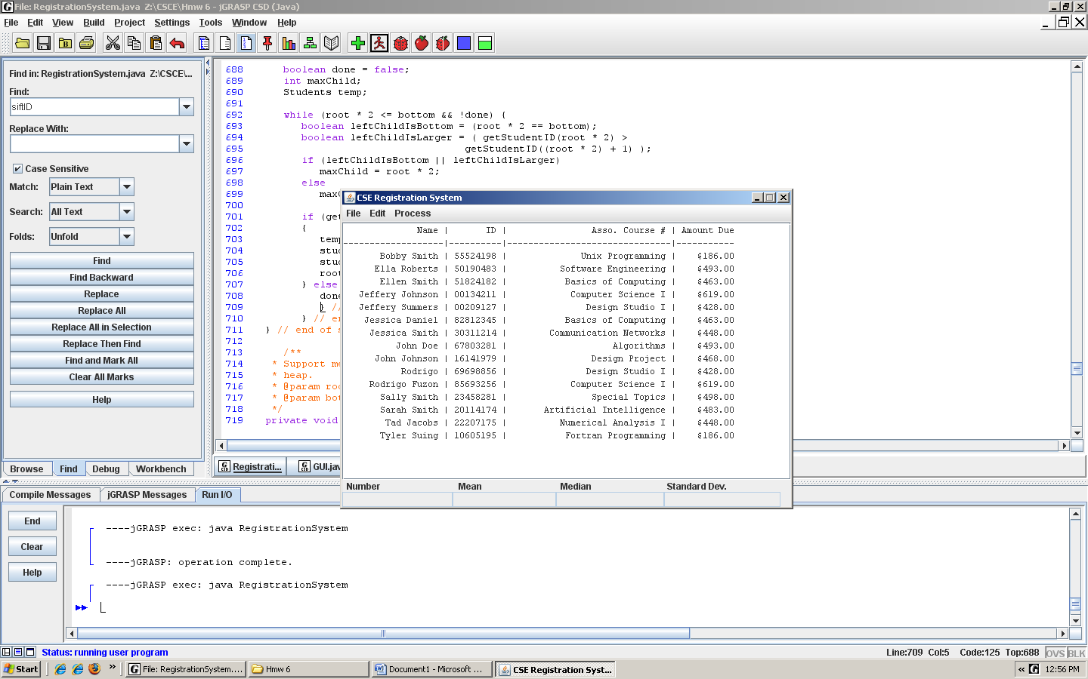Sort by Name
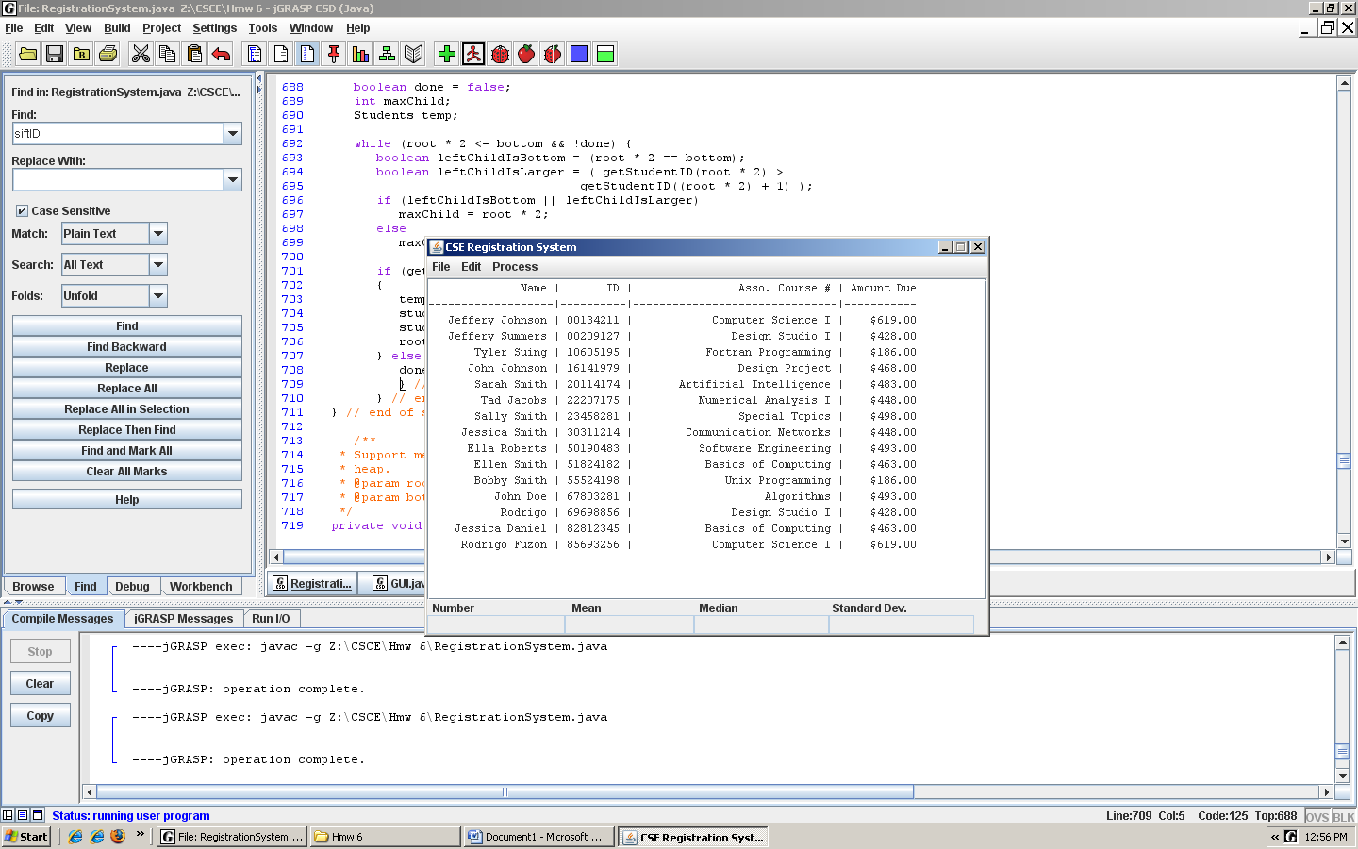
Sort by ID.
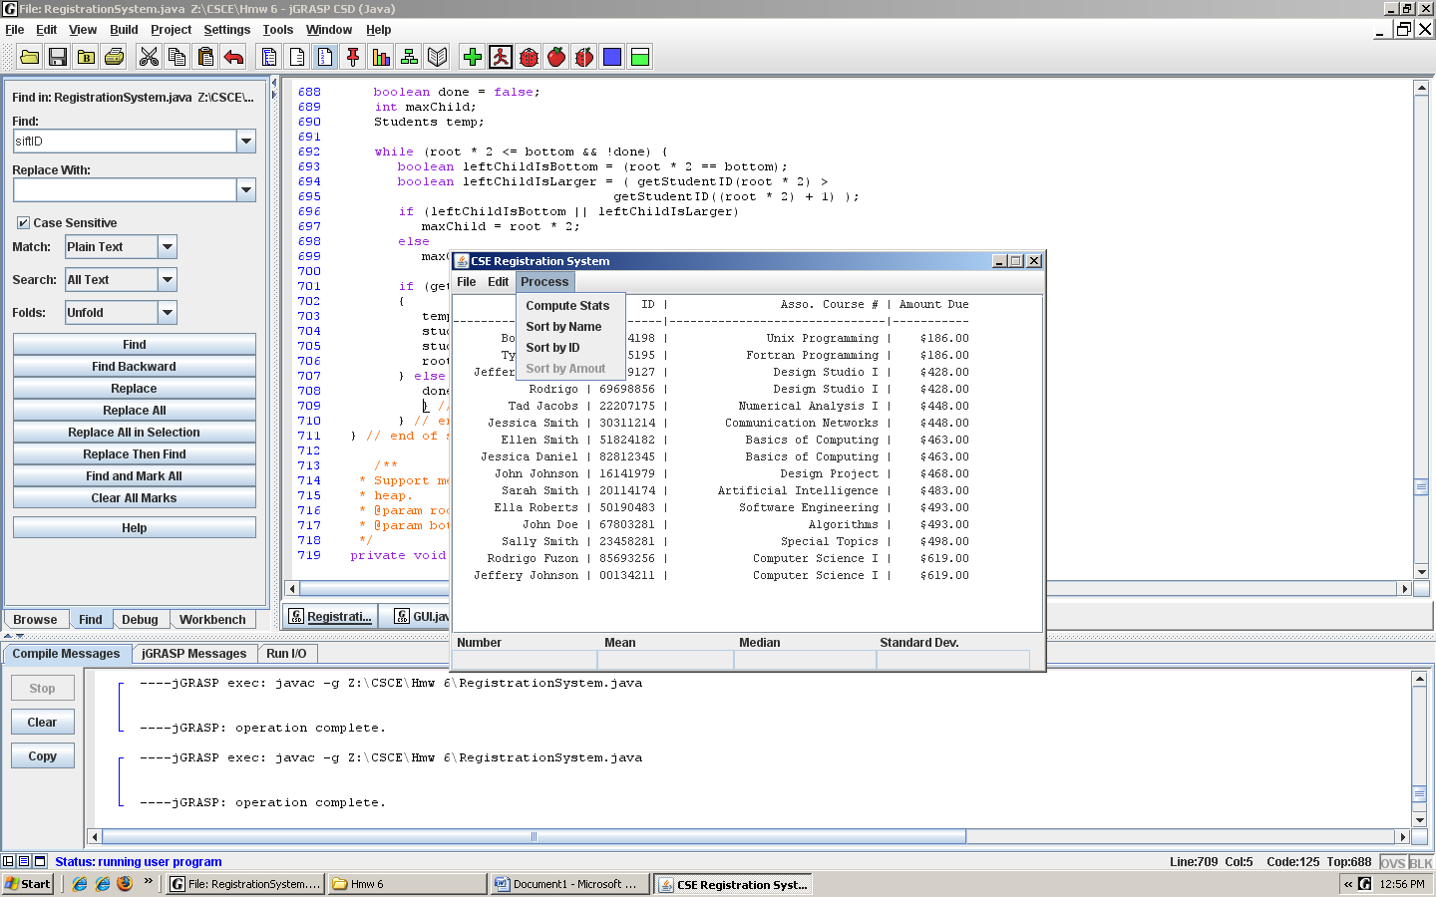
Sort by amount. Every time clicked on a Process, the clicked action gray it out.
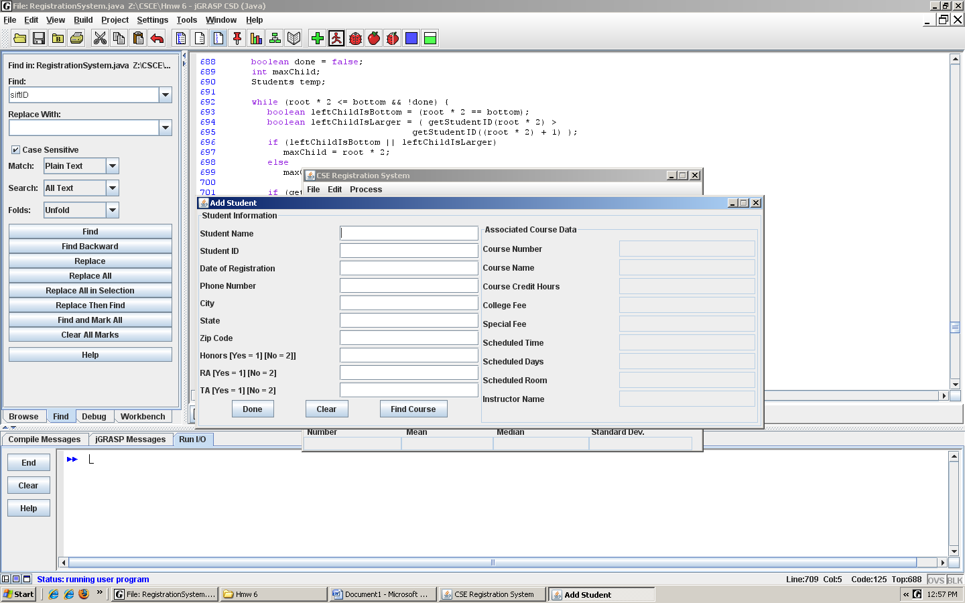
Adding Student, Honors info, Ra and TA. Typing 1 selects the info for Yes and 2 for No.

